Project Design Phase-II
Data Flow Diagram & User Stories

Date | 20 October 2026
Team ID | Niharika Suhane
Project Name | IMovies - Movie ticket booking made simple.
Maximum Marks | 4 Marks

Data Flow Diagrams:

IMovies – Movie ticket booking made simple
A Data Flow Diagram (DFD) illustrates how data moves within the IMovies – Movie Ticket Booking Made Simple platform. It shows how users interact with the system, how movie and showtime information is processed, how seat availability and booking details are managed, and how payment and notification services communicate with the application.

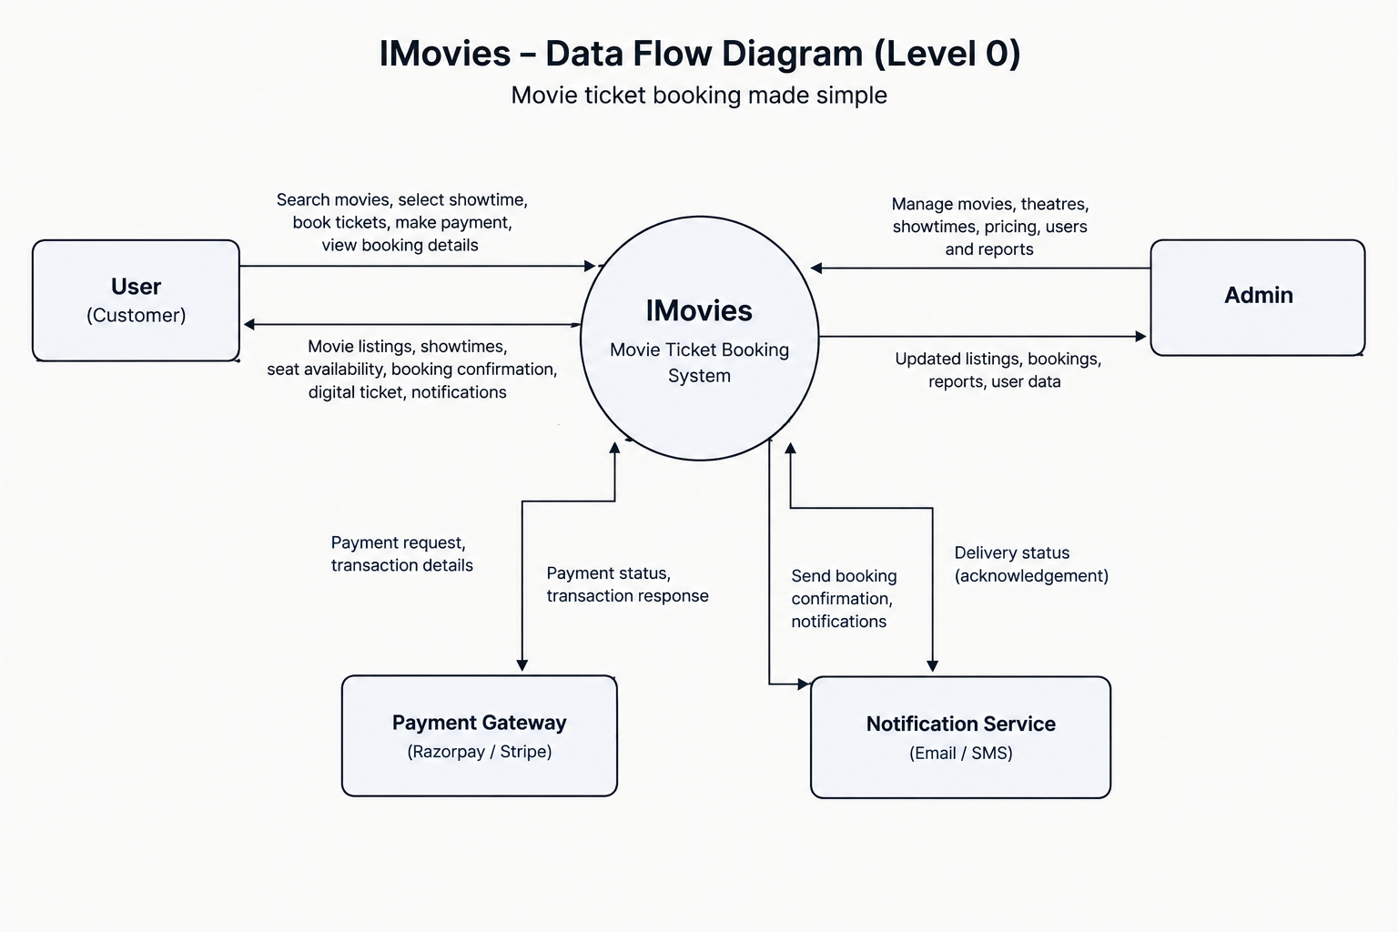

User Story Table – IMovies
User Type | Functional Requirement (Epic) | User Story / Task | Acceptance Criteria | Priority | Release
User | User Authentication | As a user, I can sign up and log in securely. | User can register, log in and access their account. | High | Sprint 1
User | Movie Browsing | As a user, I can browse and search available movies. | Relevant movies appear based on the search and filters. | High | Sprint 1
User | Showtime Selection | As a user, I can select a theatre, date and showtime. | Available shows and timings are displayed correctly. | High | Sprint 2
User | Seat Selection | As a user, I can view seat availability and select seats. | Unavailable seats cannot be booked by another user. | High | Sprint 2
User | Ticket Booking | As a user, I can book movie tickets for my selected seats. | Booking is confirmed only after successful processing. | High | Sprint 2
User | Payment Processing | As a user, I can pay securely for my movie tickets. | Payment status is verified and recorded accurately. | High | Sprint 3
User | Digital Ticket | As a user, I can receive and view my digital ticket. | Ticket displays booking ID, movie, showtime and seat details. | High | Sprint 3
User | Booking Management | As a user, I can view my previous and upcoming bookings. | Booking history displays accurate ticket details. | Medium | Sprint 4
User | Notifications | As a user, I can receive booking confirmation notifications. | Confirmation is sent after the booking is successfully completed. | Medium | Sprint 4
User | Reviews & Ratings | As a user, I can rate and review a movie I watched. | Valid reviews are saved and displayed appropriately. | Medium | Sprint 4
Admin | Movie Management | As an admin, I can add, update or remove movie listings. | Changes are reflected in the movie catalogue. | High | Sprint 1

Conclusion: The DFDs illustrate how IMovies processes user requests, manages booking data, and integrates payment and notification services. The user stories define measurable acceptance criteria for implementing and testing each feature across four development sprints.

